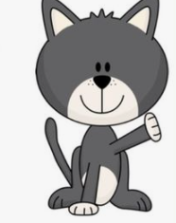**Read the story اقرأ**

I had a cat

Her name is Pat

Pat is a fat cat

I love Pat

**Write the name of your family member**

**اكتب اسم عضو العائلة في المربعات**

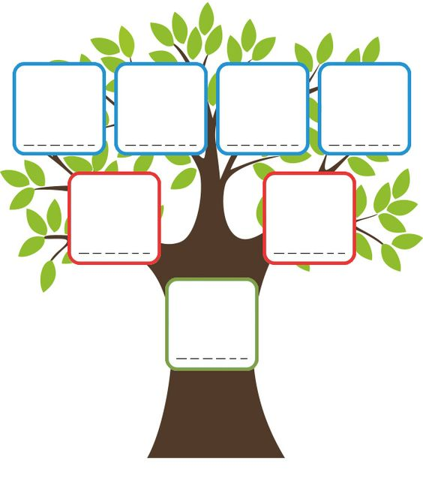

**Baby**

**Sister**

**Brother**

**Mother**

**Father**

**Grandfather**

**Grandmother**

رابط اللعبة <https://wordwall.net/play/4653/819/138>.