**اقرا القصة Read the story**

**Zac the rat الفار زاك**

**Zac is a rat Zac sat on a can**

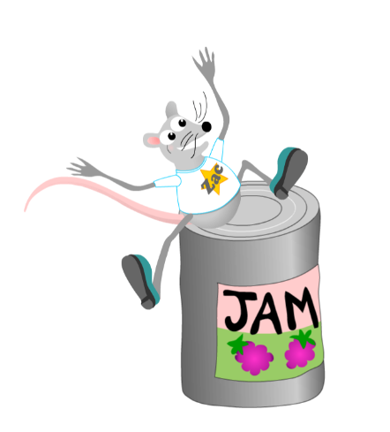

**Zac had a pan Zac had a fan**

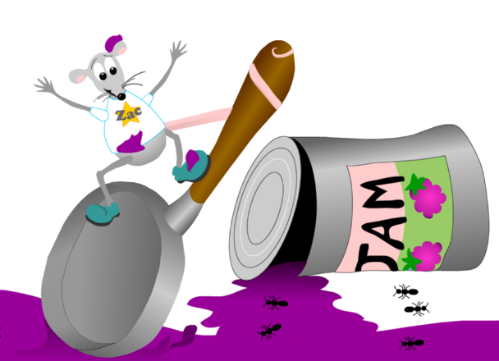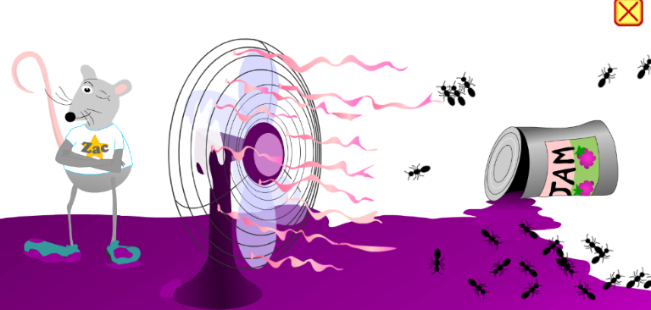

**Zac had a nap**

