**Family members**

**افراد العائلة**

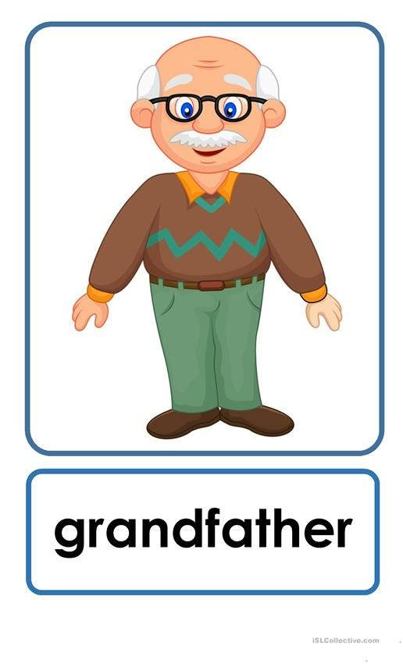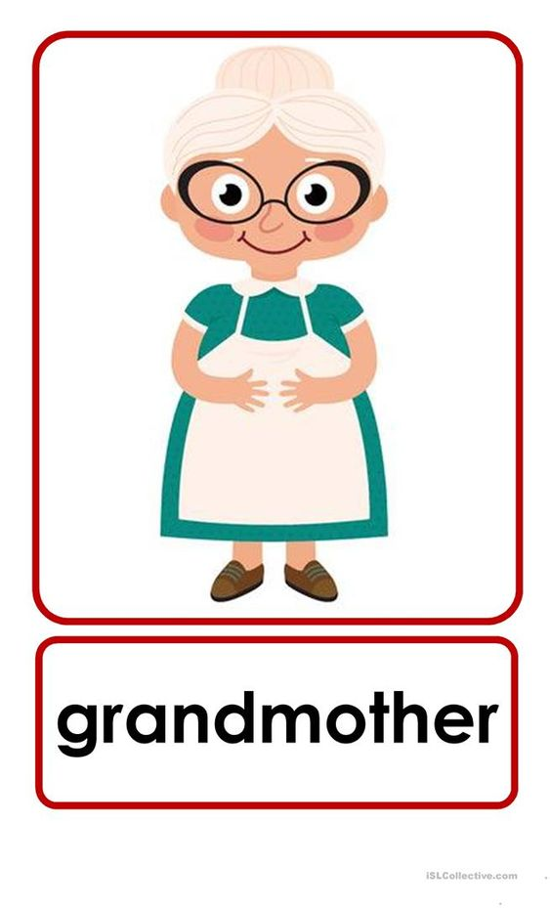

**جد**

**جدة**

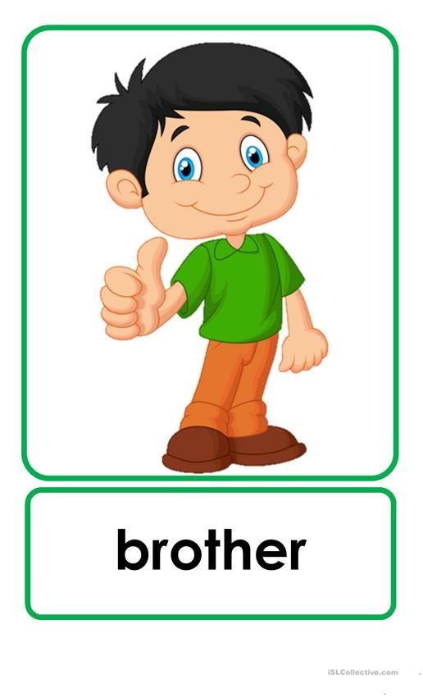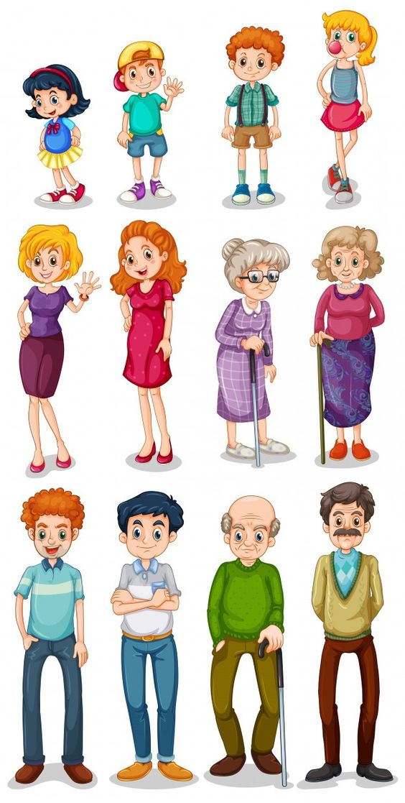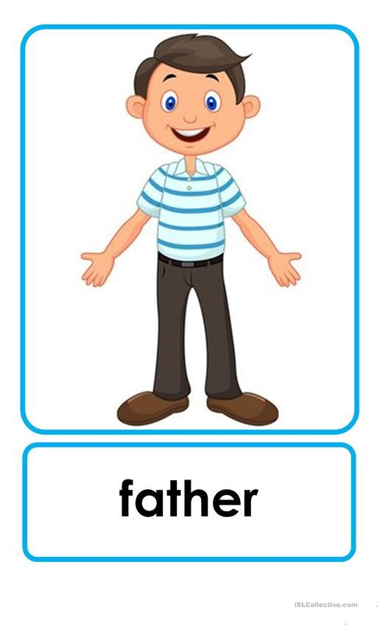

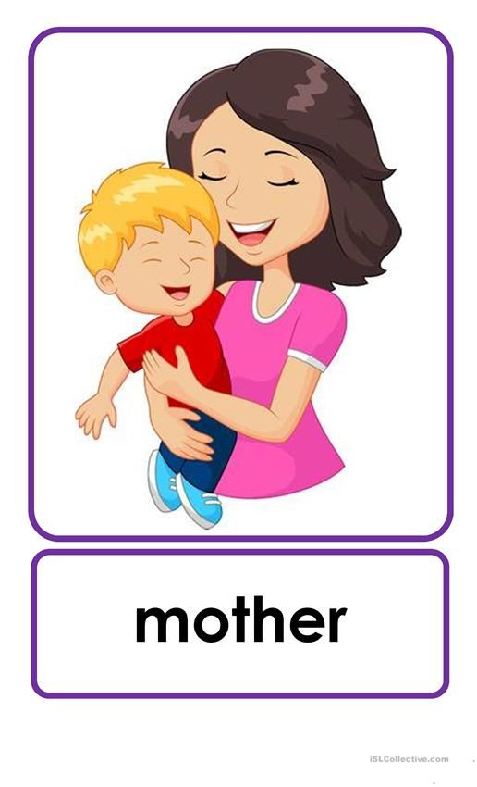

**أب**

**أخ**

**أم**

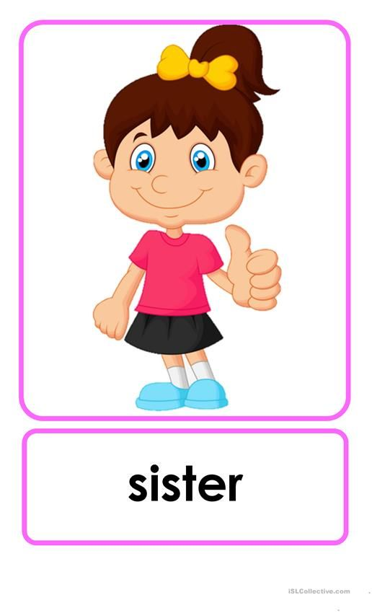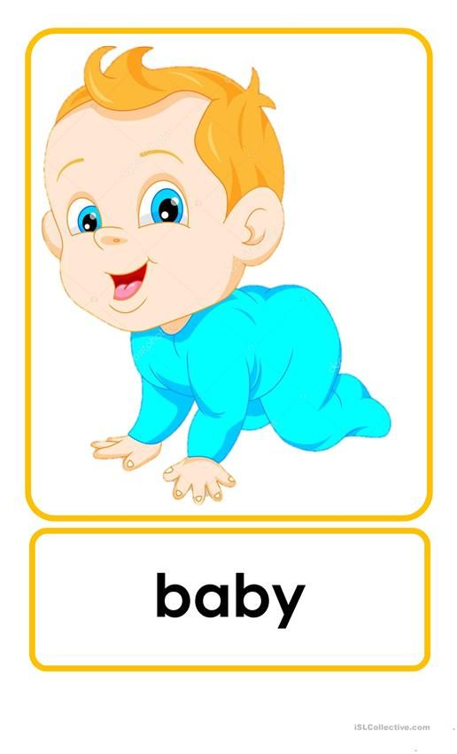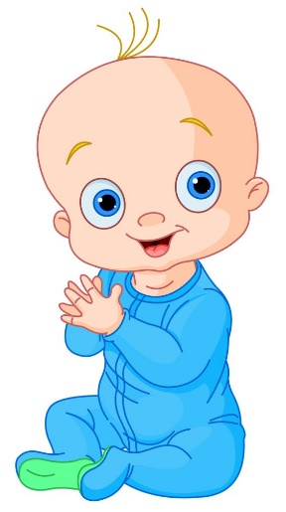

**أخت**

**طفل**

Write your family member's name اكتب اسم فرد عائلتك

Grandmother _________.

Grandfather __________.

Father __________.

Mother __________.

Sister __________.

Brother _________.

Baby ___________.

رابط اللعبة

اضغط هنا " <https://wordwall.net/play/5213/569/819>"